Our Ref: _______________ Your Ref: ________________________ Date: __________________

Baptist Church

Baale Yaku Site Area, P. O. Box 644,

Ogbomoso, Oyo State. Tel. 07052425407

Email: [newsprinbaptistchurch@gmail.com](mailto:newsprinbaptistchurch@gmail.com)

Website: newspringbc.comze.com

NEW SPRING

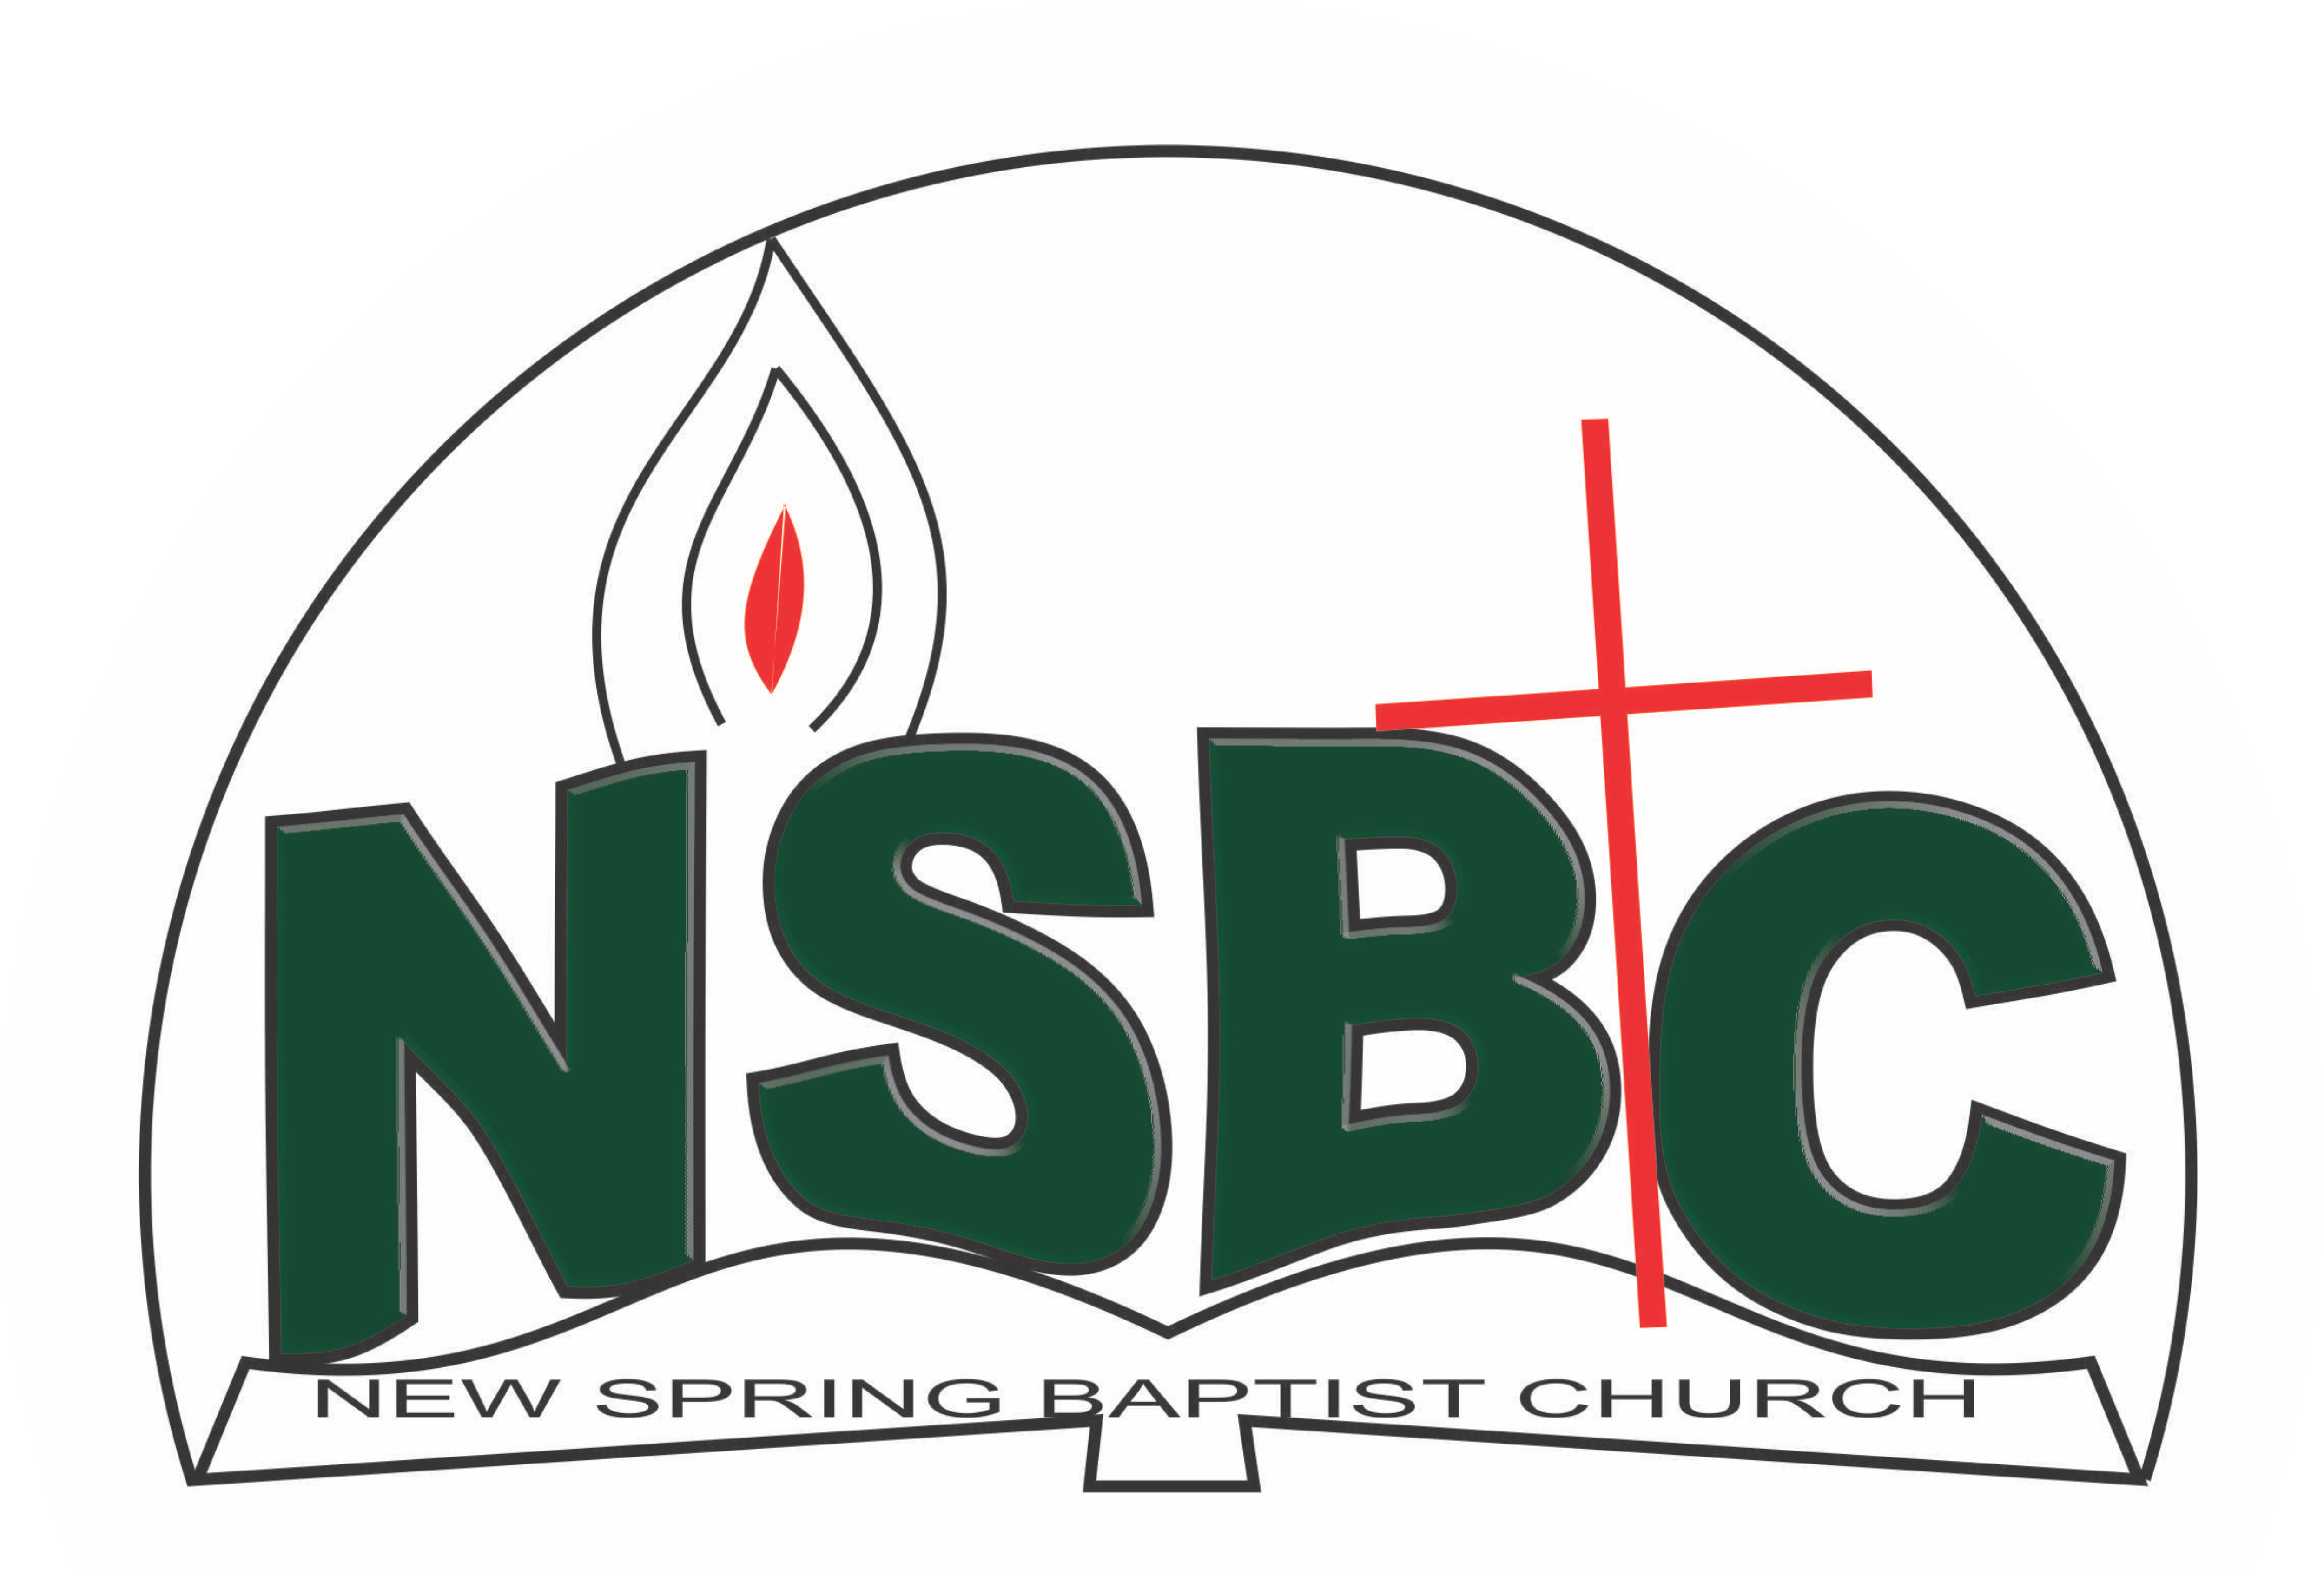

December 27, 2021

Dear Mr. Yemi Alamu,

Nomination to Serve as an Officer and Worker in the Church in 2022

Calvary greetings in the precious name of our Lord and Saviour Jesus Christ. It is our pleasure to inform you that, at the Church-in-Conference held onDecember 19, 2021, the Church ratified your nomination to serve in the following areas between January 1 and December 31,2022:

1. Member, Building Committee under the Chairmanship of Dn. OmoOlorun Olupona
2. Member, Counselling& Follow-up Committee under the chairmanship of Dns. Christiana Oketoobo
3. Member, Health Committee under the chairmanship of Mrs. Nia Olupona
4. Member, Marriage Counselling under the chairmanship of Rev. Kayode Oke
5. Member, Membership Committee under the chairmanship of Mr. Johnson Olaniran
6. Chairman, Church History Committee
7. Member, Mission and Evangelism Committee under the chairmanship of Dn. Ayinde Ezekiel
8. Member, Nominating Committee under the Chairmanship of Dn. Ayinde Ezekiel
9. President, MMU and
10. Church Council member
11. Church Auditor

Please refer to the table below for the key functions of each of these roles. Details can be found in the Church constitution. You are strongly encouraged to become familiar with the tasks as stated in the document. There will be an orientation of the Church workers on January 15, 2022 at 8:30 a.m. on the church premises. Please ensure you participate in this training.

“Now it is required that those who have been given a trust must prove faithful. I Corinthians 4:2”. May God find you faithful in the task He has assigned to you.

| Domain | Key function of Office, Department or Committee |
| --- | --- |
| Building Committee | The purpose of the committee is to safeguard the interest of the Church in any building project the Church embarks upon |
| Counsellors & follow-up | To help decision makers understand and follow through on their decisions |
| Health | The committee is to support the Church Pastor in providing professional guidance to the Church in health related matters of the Church members. |
| Marriage counseling | Responsible for acquainting prospective couples of behavioural patterns expected of those who wish to get married in the Church or those who request the Church to participate in their wedding ceremony |
| Church History | The purpose of the committee is to document past and current key events in a systematic manner so that the evolution of the Church can be understood when her history is reviewed in the future |
| President, MMU | To provide support to the Church Pastor in ensuring that the men of the Church are moving forward with the Great Commission, breaking new frontiers and be responsible for the efficient running of the Union – The Men’s Missionary Fellowship and the Royal Ambassador. |
| Church Council member | The Church Council is the governing body of the Church whose membership, under the leadership of the Holy Spirit, holds one another mutually accountable with respect and love and sees to the smooth running of the Church. |
| Member, Membership Committee | Responsible for the overall management of the membership of the Church |
| Member, Mission & Evangelism | The committee is responsible for the mobilization of Church members for soul winning activities. |
| Church Auditor | To provide support to the Church Pastor in ensuring that financial records of income and expenditure presented by the Treasurer are correct and accurate |

Thank you for accepting to serve in this Church.

Yours in His service

Olusayo Okediji Blessed Agboola

Church Secretary Chairman, Nominating Committee